Our Best Circuit
The name of the group/ The roles of each person:
Cactus→ Irene Sandín →Secretary
Sandra Román→ Helper
Anna Rubio →Digital
Denzel Ison → Coordinator
Alex Roche→ Speaker
Xènia Acosta → Controler
All necessary equipment (type and quantity): We need:- The elastic bands, bench, mats and the “espatlleras”
Time, duration, repetetition:
Duration for each exercise is 30’’ and two times.
We organizated: In 5 groups.
Our Circuit:
- Bridge : Lying on your back, this exercise is one of the most popular because of its low difficulty. Raise the trunk and two seconds keep it steady, low and start again. If you want more difficulty, not lean the ass on the floor to rest. GLUTEUS.
- Leapfrog: Start squatting on the ground and put both hands in front of you. Now jump in the air and tap your heels together.Strengthens the GLUTEUS, HAMSTRINGS (isquiotibials),QUADRICEP and LEG MUSLES.
- Pushups:serve to combine with other pectoral exercises at home as they help us stimulate different fibers.PECTORALS
- Face Pull: We must position-somewhere before where to place a rubber band. I will post back straight and with each hand to the band. We must pull the band toward our face while separating hands. TRICEPS
- Lateral leg lift: We must stand sideways against the wall to protect our back, i then move our leg up vertically.SIDEWAYS

- Griddle:you have to wear prone lean on the arms up straight. ABS
- Toe toching:You have to be face up and try to touch your toes and lifting your back with your legs straight. ABS
- High knees:You have to run on your site and up your knees as high as you can. BICEPS FEMORIS
- Lateral Pillar Bridge:Lying on your side with your forearm on the ground under your shoulder, your feet split with the top leg forward. With your body in a straight line and your elbow under your shoulder, push your hip off the ground, creating a straight line from ankle to shoulder and keeping your head in line with your spine.
- Elevations Isometric heels: Stand with legs apart at shoulder width apart, take off the heels of the land to sustain us for 20 to 30 seconds. TWIN MUSCLE

Record the entire process (from creation to execution of fellow) Our group decided that we will record all students doing the exercise and our final product will be a video. And we insert it in our Weebly. But you must correct in Anna’s Rubio Weebly.
For Worming up: For worm up our body we do the game of “cadena total” or “La araña”.
For return to calm: We do the typical stretching.
Stations:
- Bridge/Leapfrog → Anna Rubio
- Pushups/Face Pull→ Sandra Roman
- Lateral leg lift/High knees→ Xènia Acosta
- Toe toching/Griddle→ Denzel Ison
- Squats/Lateral Pillar Bridge Irene Sandin
Controler of time in “OUR CIRCUIT” → Anna Rubio
Evaluation: At the end of the sesion our group take a list of the class and evaluate and talk of the work of every student.
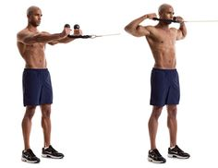FACE PULL

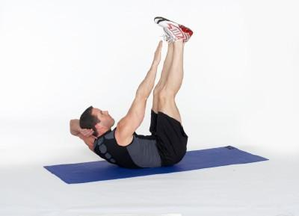TOE TOCHING
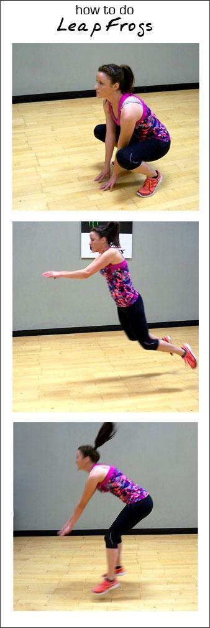LEAPFROG
LATERAL LEFT LIFT
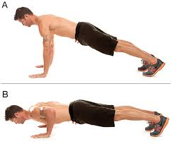PUSH UP
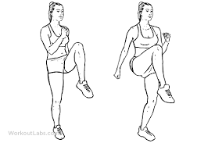HIGH KNEES
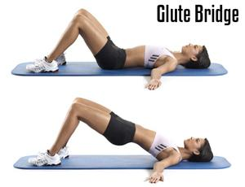BRIDGE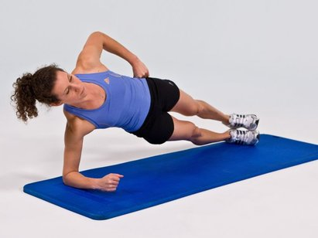LATERAL PILLAR BRIDGE
GRIDDLE
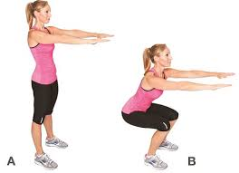SQUATS

